Key management service(KMS) & Secret Manager

Task Title
Create an S3 Bucket with SSE Encryption and Access via IAM User

Objective
To create an Amazon S3 bucket with default server-side encryption using AWS KMS (SSE-S3), upload an object, create an IAM user with S3 access, and validate access to the object using the generated S3 URL.

Prerequisites
- AWS Account with console access
- IAM permissions to create S3 buckets and IAM users
- Basic knowledge of S3 concepts (Bucket, Objects, Permissions, SSE)

Step-by-Step Implementation

1. Create an S3 Bucket
- Navigate to: AWS Console → S3 → Create bucket
- Enter bucket name: test-s3-encry-kms
- Select region: US East (N. Virginia) us-east-1
- Bucket type: General purpose
- Object Ownership: ACLs disabled (recommended)
- Block Public Access: Leave default – all public access blocked
- Default Encryption:
  - Select: Server-side encryption with Amazon S3 managed keys (SSE-S3)
  - Enable Bucket Key to reduce KMS request costs
- Click Create bucket

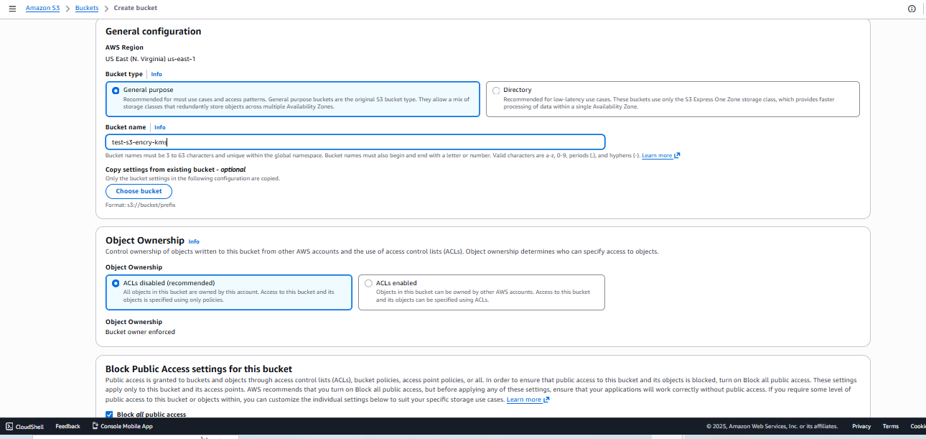
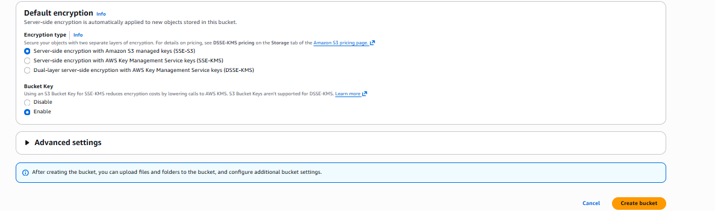
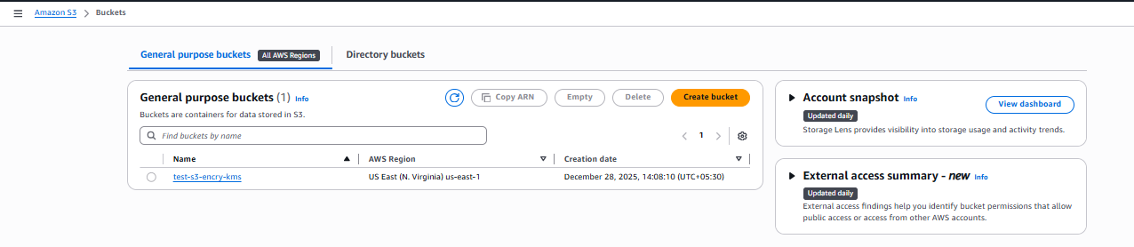

2. Upload a Test File
- Open the bucket
- Click Upload
- Select a text file: sample.txt
- Confirm upload → Upload succeeded

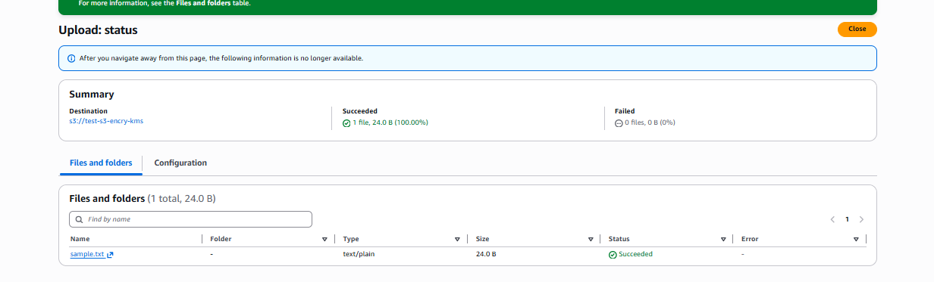

3. Verify Default Encryption
- Open the uploaded object
- Under Properties, confirm:
  - Encryption: AES256 (SSE-S3)
  - Bucket Key: Enabled

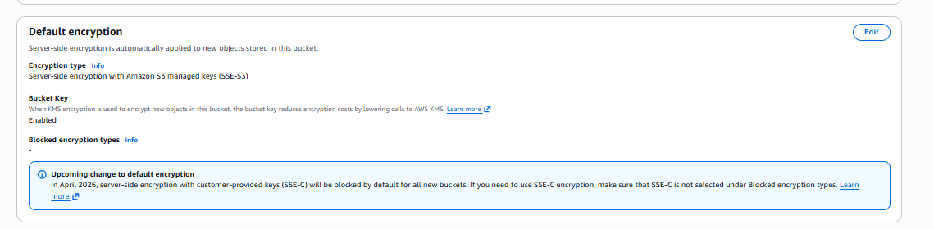

4. Create IAM User for S3 Access
- Go to IAM → Users → Create user
- Enter username: test-s3
- Enable Console access and set a password
- Click Next
- Attach policy: AmazonS3FullAccess
- Complete user creation and download credentials

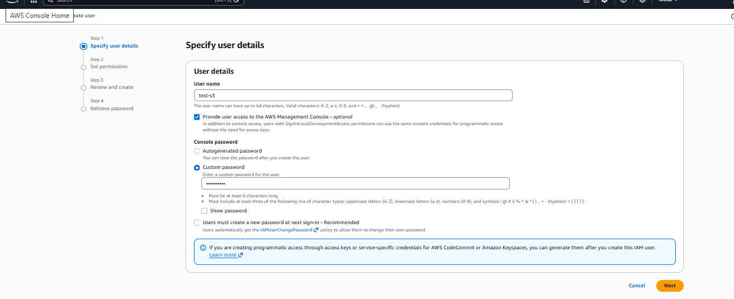
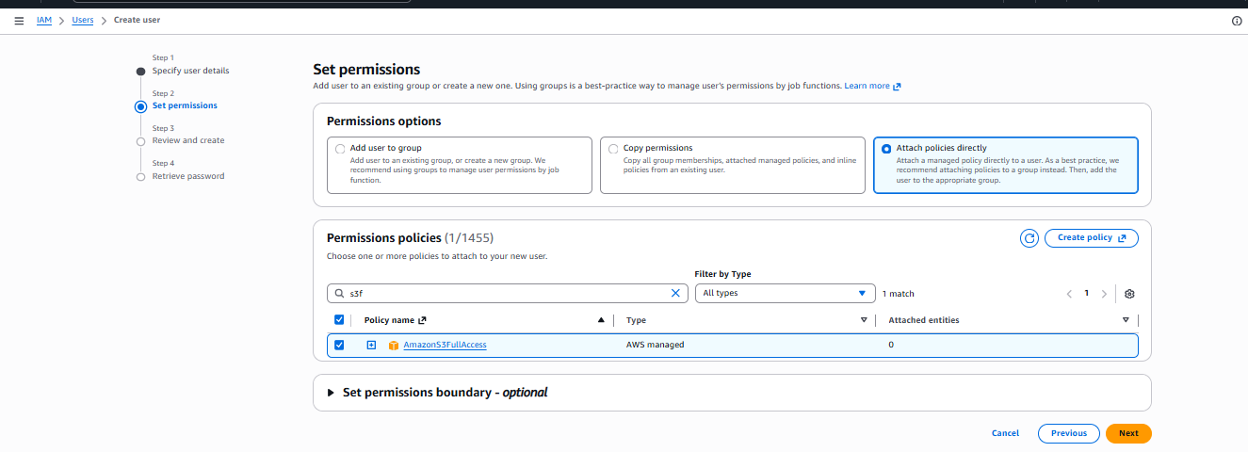
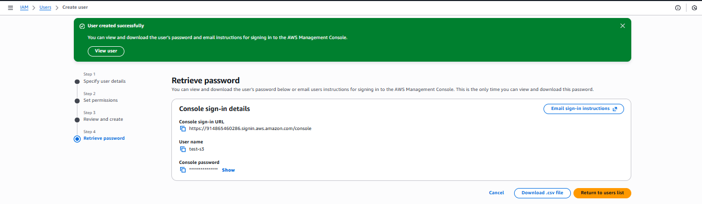

5. Validate Object Access
- Copy the Object URL of sample.txt
- Open in browser (Incognito window)
- Since public access is blocked, URL will contain a pre-signed request temporary signature
- File content loads:
hello, welcome to india

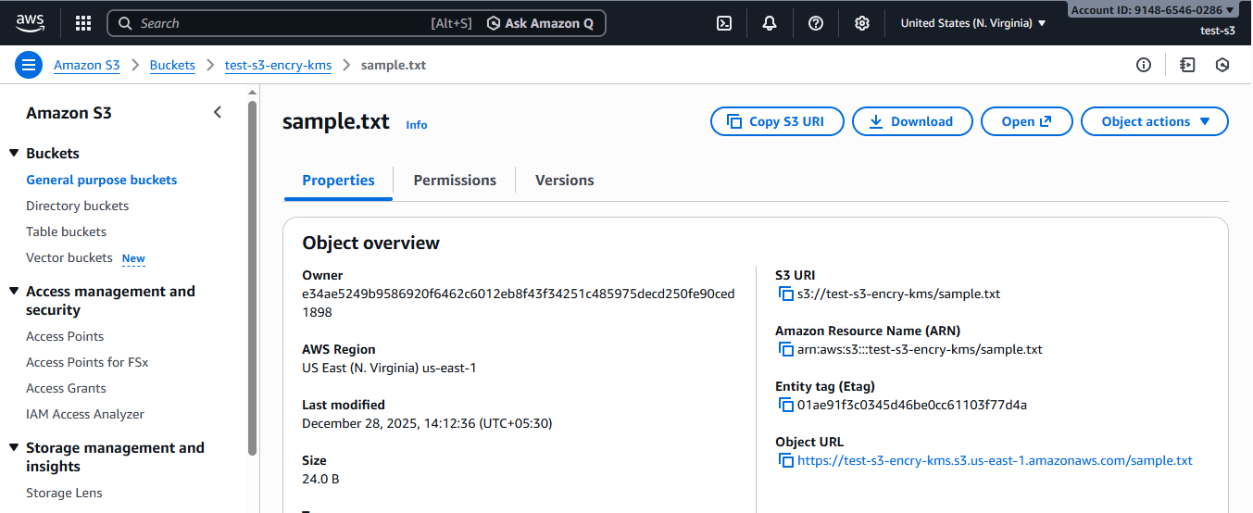
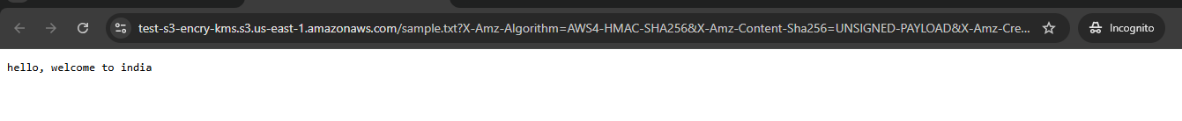

Validation Steps
Validation Item | Status
Bucket Created Successfully | ✅
Default Encryption with SSE-S3 Verified | ✅
IAM User Created & Granted S3 Access | ✅
Object Uploaded Successfully | ✅
Access via signed URL Tested | ✅

Issues Faced
Issue | Resolution
Public URL not accessible normally | Expected behavior due to Block Public Access settings. Access using IAM or signed URL.
Confusion between SSE-S3 and SSE-KMS | SSE-S3 uses AWS-managed keys; SSE-KMS requires specifying a KMS key.

Conclusion
An S3 bucket with default SSE encryption was successfully created, and access was validated through an IAM user. By default, objects are encrypted with SSE-S3, and public access is restricted to ensure data security. The setup confirms that the bucket and objects are protected while still allowing controlled access via IAM or signed URLs.

Enable Server-Side Encryption on S3 using Customer Managed KMS Key (SSE-KMS

Task Title
Enable Server-Side Encryption on S3 using Customer Managed KMS Key (SSE-KMS)

Objective
To create a Customer Managed Key (CMK) in AWS KMS, assign permissions, enable bucket encryption using SSE-KMS, and validate access by uploading and downloading encrypted S3 objects.

Prerequisites
- AWS Account with IAM access to create KMS Keys and S3 buckets
- Permissions required:
  - kms:CreateKey
  - s3:PutEncryptionConfiguration
  - s3:GetObject
  - s3:PutObject
- Basic understanding of AWS IAM, S3, and KMS

Step-by-Step Implementation

1️⃣ Create KMS Key
- Go to AWS Console → KMS → Customer managed keys → Create key
- Select:
  - Key type: Symmetric
  - Key usage: Encrypt and decrypt
- Click Next

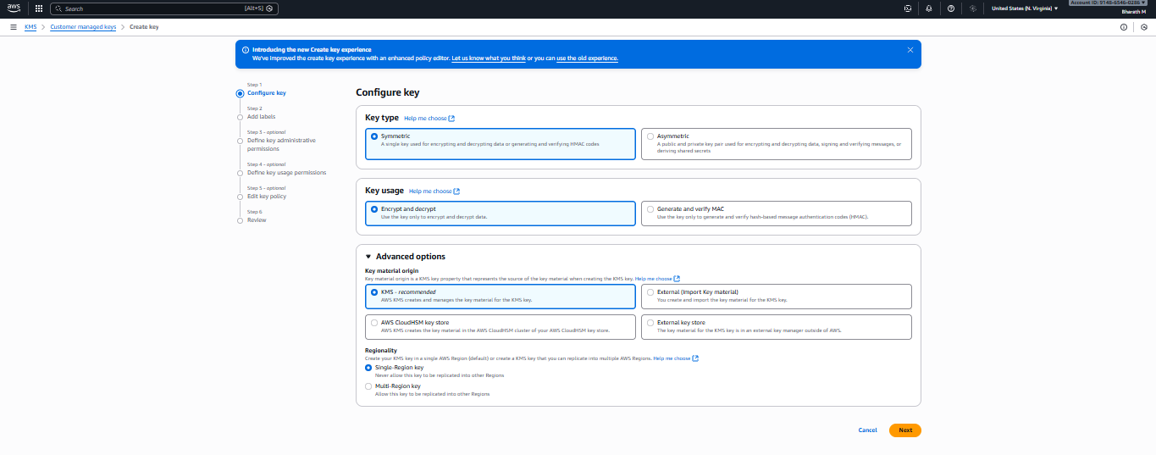

2️⃣ Add Labels
- Alias: test-s3
- Description (optional): Key for S3 encryption testing
- Click Next

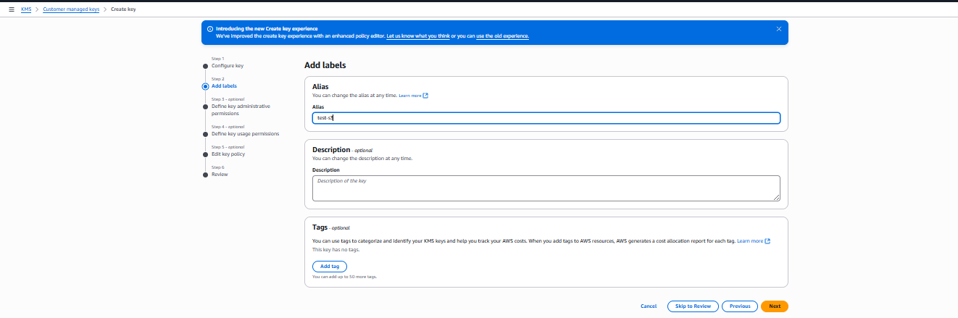

3️⃣ Define Administrative Permissions
- Select IAM user/role to administer the key (optional)
- Click Next

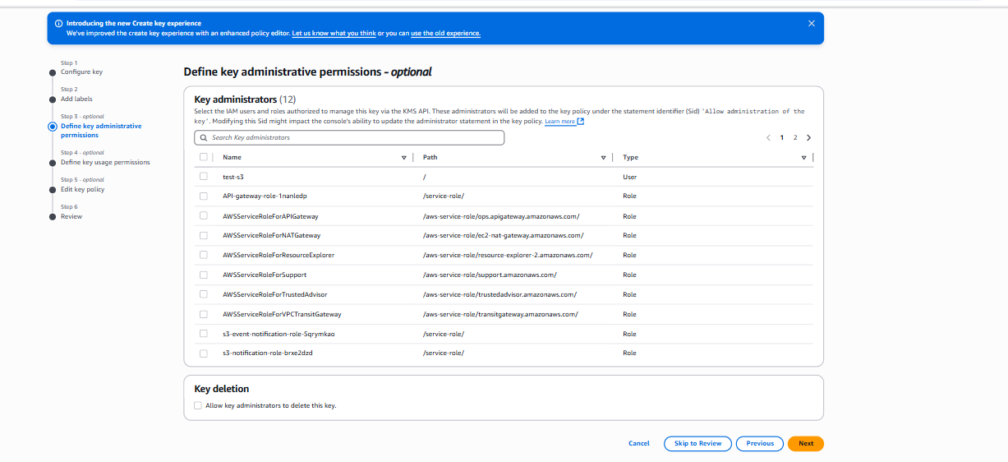

4️⃣ Define Key Usage Permissions
- Select the IAM user test-s3 as a key user (so they can use the key for S3 encryption/decryption)
- Click Add → Next

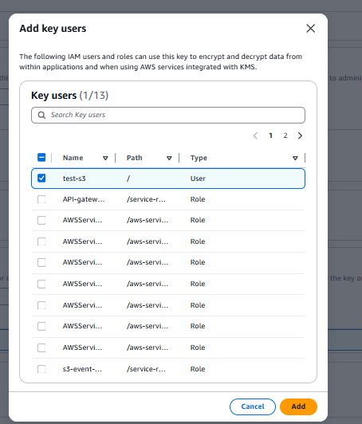

5️⃣ Review and Create
- Confirm selections
- Click Create key

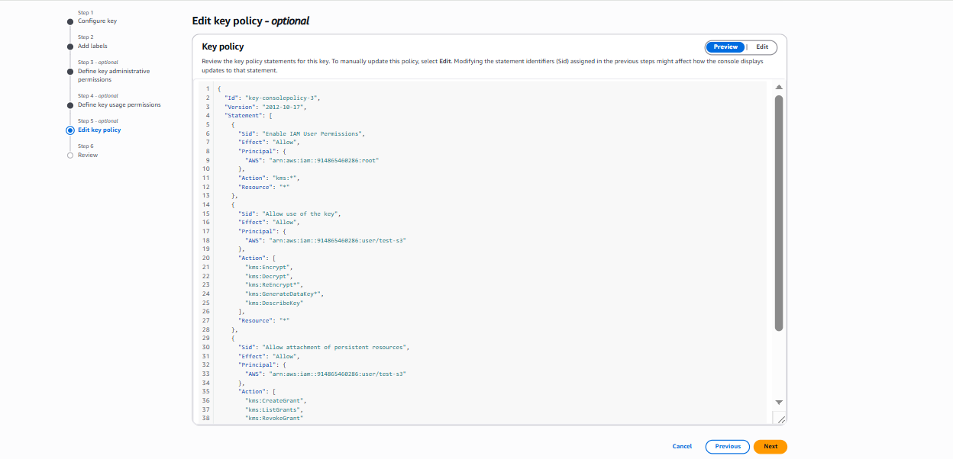
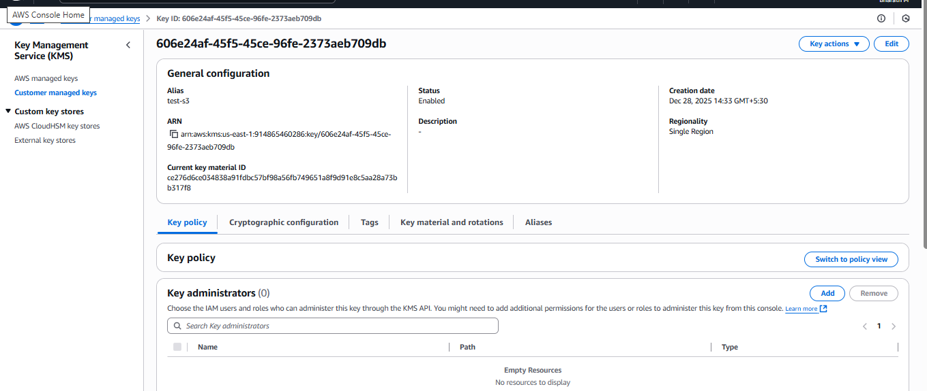

6️⃣ Enable SSE-KMS on S3 Bucket
- Go to S3 → test-s3-encry-kms bucket
- Navigate to Properties → Default encryption
- Choose:
  - SSE-KMS
  - Select Key → arn:aws:kms:us-east-1:xxxx:key/606e2a...709db
- Save changes

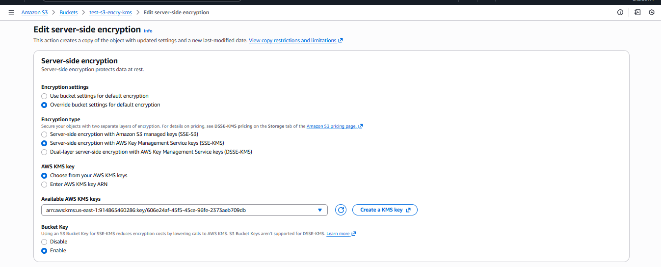

7️⃣ Upload & Test Object Encryption
- Upload file: sample.txt
- Confirm encryption in object properties:
  - Encryption type: aws:kms
  - KMS key: test-s3

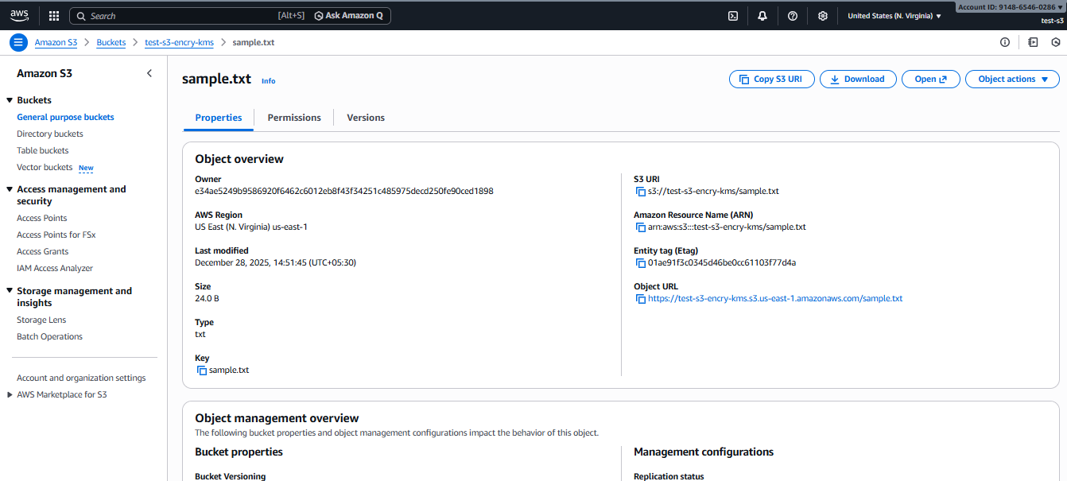

Validation Steps
Step | Validation | Expected Result
1 | Check Object metadata | Shows aws:kms encryption
2 | Download object via console | Download succeeds
3 | Public access test via URL | File should NOT be publicly accessible unless bucket policy allows
4 | Validate KMS key usage logs | CloudTrail logs show Decrypt API usage

Output Screenshot Observation
- Public URL still displayed content — this means:
  - Bucket policy or ACL might be allowing public access temporarily.
  - Encryption protects the data at rest, not viewing access.
🛑 Encryption ≠ Blocking access.
To block public access, enable:
- Block Public Access settings on S3
- Remove any public bucket policy

Issues Faced
Issue | Reason | Solution
File content visible via public URL | Bucket/object ACL is public | Enable Block Public Access, remove public ACL
Key cannot be used by a user | IAM user lacks kms:Decrypt permission | Add IAM policy granting KMS permissions
Object upload fails with AccessDenied | Encryption key not authorized | Add user as Key User under KMS

Conclusion
Successfully configured and validated S3 server-side encryption (SSE-KMS) using an AWS Customer Managed Key (CMK). The bucket now encrypts all objects using the selected KMS key, ensuring data-at-rest protection with controlled access via IAM and KMS policies.

Secret manager
Create a RDS managed in aws secret manager

Task Title
Create an Amazon RDS MariaDB Database with AWS Secrets Manager Managed Credentials

Objective
To provision a MariaDB database instance in Amazon RDS using the Full configuration option and enable automatic credential management via AWS Secrets Manager, ensuring secure and centralized password handling.

Prerequisites
- AWS account with administrative access
- VPC, Subnets, and Security Groups already created
- Basic knowledge of database concepts
- Internet connection to access AWS Console

Step-by-Step Implementation

1. Navigate to RDS Dashboard
- Go to AWS Console → RDS → Databases → Create database
- Select Full configuration

2. Choose Engine
- Engine type: MariaDB
- Select version: (Choose latest stable version)

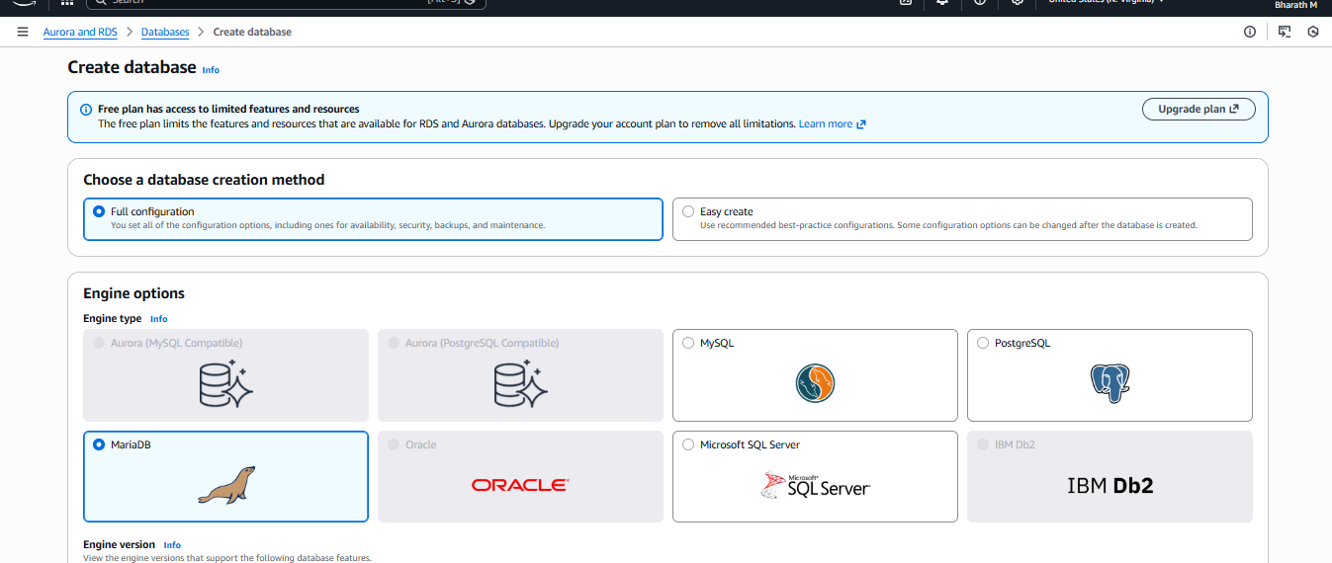

3. Settings
- DB instance identifier: e.g., mariadb-demo-db
- Master Username: admin

4. Credential Management
- Select: Managed in AWS Secrets Manager – most secure
- AWS will automatically create a secret for username & password
- Select encryption key: aws/secretsmanager (default)

Create DB
- Review and click Create database
- Wait until status changes to Available

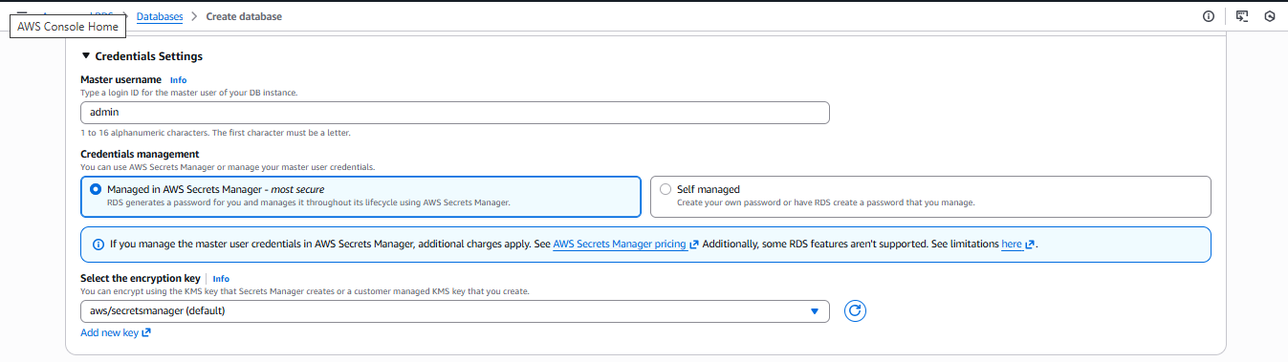
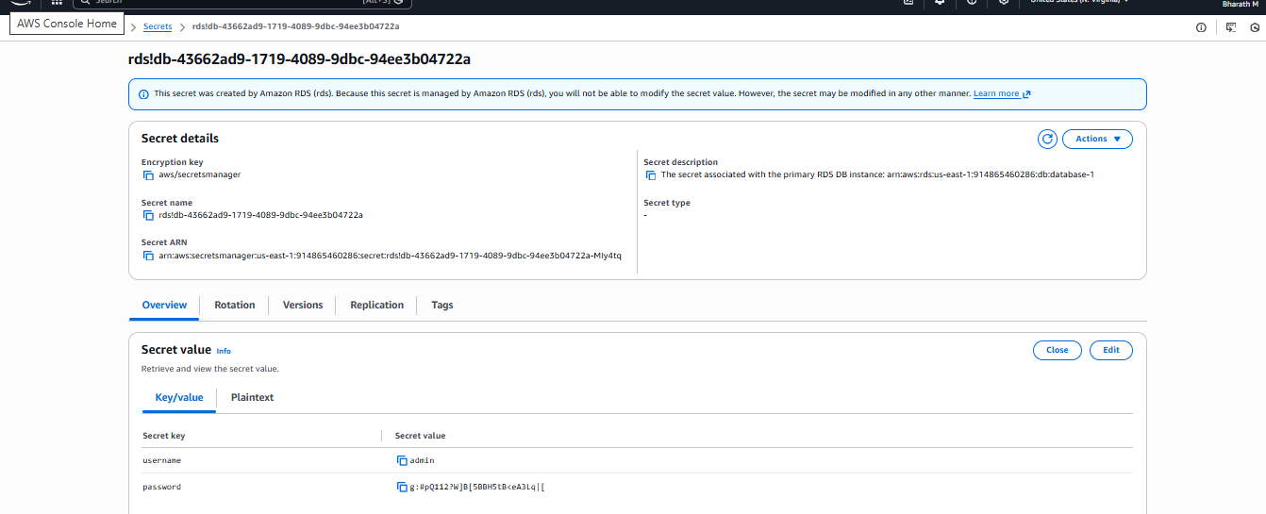

Validation Steps

1. Validate Secret in Secrets Manager
- Go to AWS Secrets Manager → Secrets
- Verify the generated secret contains:
  - Username
  - Password
  - ARN and DB connection details

2. Connect to Database
Use a MariaDB client / MySQL Workbench / CLI:
mysql -h <endpoint> -u <username> -p
Retrieve password from Secrets Manager → View plaintext (if permitted).

Issues Faced & Resolutions
Issue Encountered | Cause | Resolution
Cannot connect from local system | SG not allowing inbound traffic | Allow port 3306 for required IP in security group
Password not visible/editable | Managed by RDS, not manually editable | Use Rotate secret or modify via RDS password reset
Endpoint not resolving | DB still initializing or VPC misconfiguration | Wait until DB status is available & check DNS enabled in VPC

Conclusion
A MariaDB RDS instance was successfully deployed with AWS-managed credentials stored in Secrets Manager. This configuration improves security by automating password lifecycle and reduces operational overhead. The database is ready for integration with applications and secure connectivity.

Create a new secret key in secret manager

Task Title
Create and Store a Secret in AWS Secrets Manager

Objective
To securely store sensitive information such as usernames, passwords, or API keys in AWS Secrets Manager, ensuring encrypted and centralized credential management for applications and services.

Prerequisites
- AWS account with access to Secrets Manager
- IAM user/role with permissions:
  - secretsmanager:CreateSecret
  - secretsmanager:GetSecretValue
  - kms:Encrypt and kms:Decrypt (if using a customer-managed KMS key)
- Basic understanding of AWS console navigation

Step-by-Step Implementation

Step 1: Choose Secret Type
- Navigate to AWS Console → Secrets Manager → Store a new secret.
- Under Secret type, select Other type of secret (for custom key/value data).
- In Key/value pairs, enter:
  - Key: admin
  - Value: admin@123 (example password)
- Under Encryption key, keep the default aws/secretsmanager (or choose a custom KMS key).
- Click Next.

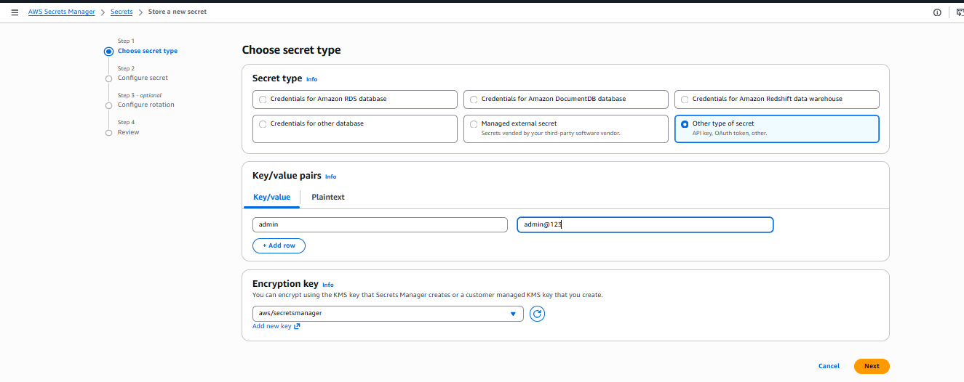

Step 2: Configure Secret
- Enter a secret name:
new-secret
- (Optional) Add a description, tags, or update resource permissions.
- Click Next.

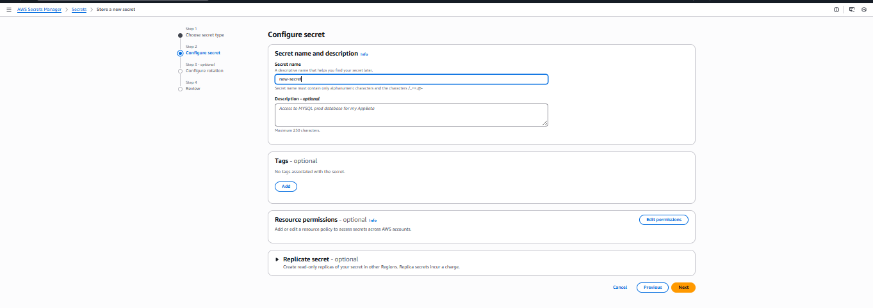

Review and Store
- Review all settings.
- Click Store to save the secret.

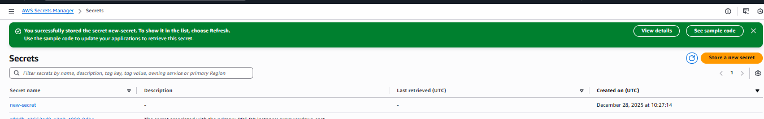

Confirm
- After creation, you will see a success message.
- The secret new-secret will appear in the Secrets list.

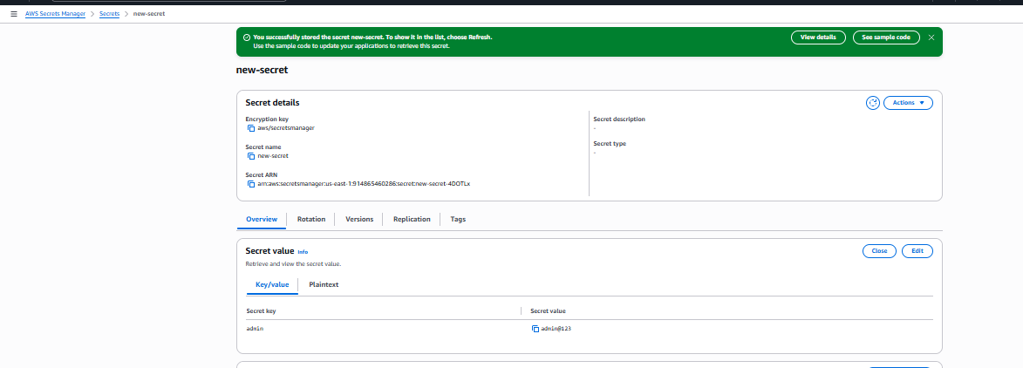

Validation Steps
- From Secrets Manager, search for new-secret.
- Select the secret and verify the stored values under Secret value section.
- Optionally, retrieve via CLI:
aws secretsmanager get-secret-value --secret-id new-secret --region <your-region>

Issues Faced
Issue | Cause | Solution
Permission denied when creating secret | Lack of IAM policy privileges | Add secretsmanager:CreateSecret policy
Unable to read secret from application | Incorrect ARN or missing decrypt permission | Verify secret ARN and ensure role has KMS decrypt access
Secret not visible in list | Region mismatch | Check AWS region in console

Conclusion
The secret new-secret was successfully created in AWS Secrets Manager with key/value pairs and encrypted using the default KMS key. The stored secret can now be securely accessed by applications and services to retrieve credentials programmatically or via AWS CLI.

